**Graph algorithms - practical work no. 3**

Andreas R. Toadere **Python** | Group 917

Problem 6: Write a program that, given a graph with costs and two vertices, finds a lowest cost walk between the given vertices, or prints a message if there are negative cost cycles in the graph. The program shall use the matrix multiplication algorithm.

**Matrix multiplication algorithm and its complexities:**

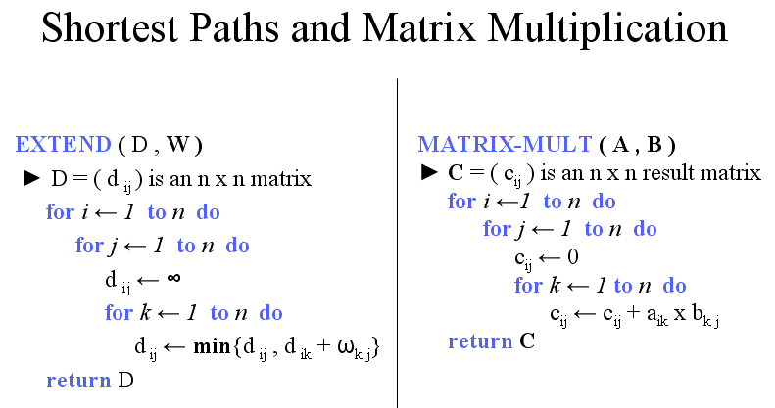

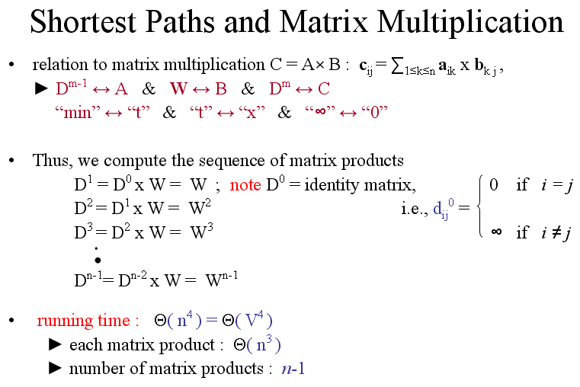

**The code of the function that calculates the lowest cost walk**

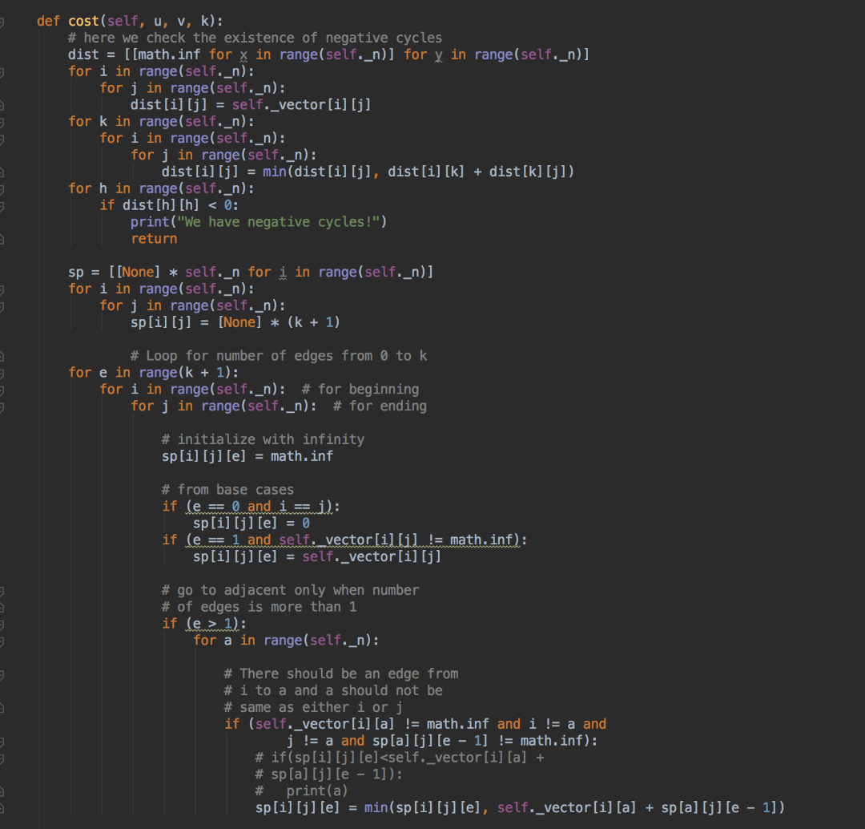

**It returns the highest level matrix because there is where the lowest walk cost is stored**

